**Name:** Abdulrahman AbdulKareem

**Title:** Comparative Analysis of XGBoost and Random Forest Algorithms for Transformer Failure Prediction using Grid Stability Data

# CHAPTER ONE

# INTRODUCTION

## BACKGROUND OF STUDY

For decades, the heart of any power grid, transformers, hum with the vital energy that fuels our world. Yet, despite their critical role, they remain vulnerable to breakdowns that cause costly downtime and disruptions. Traditional approaches, relying on fixed schedules or reactive repairs, often prove inefficient, leading to unnecessary maintenance and compromised power supply (Tianjin da xue et al., 2018). Predictive maintenance (PdM) emerges as a game-changer, transforming equipment management from reactive to proactive, leveraging the power of several prominent mode of maintenance to analyze data, it anticipates equipment failures before they strike, enabling timely interventions and optimized maintenance schedules. (Carvalho et al., 2019).

This research delves into the exciting realm of PdM for electrical equipment using machine learning-based maintenance. Instead of directly targeting transformers, it focuses on the untapped potential of electrical grid stability data. This treasure trove of information holds hidden clues about the health of individual components like transformers. By employing powerful machine learning algorithms such as Random Forest and Extreme Gradient Boosting (XGBoost), this research deciphers these clues and identifies patterns that might foreshadow transformer failures. Analyzing metrics like voltage fluctuations, frequency deviations, and load imbalances could allow us to predict potential breakdowns before they occur. Comparing the performance of these algorithms in terms of accuracy, efficiency, and interpretability will identify the most suitable tool for this task. Successful implementation could significantly reduce downtime, lower maintenance costs, and enhance grid resilience.

Ultimately, this project represents a crucial step towards smarter, more efficient, and more reliable power grids. By ensuring the uninterrupted flow of the vital energy that fuels our world, we can contribute to a brighter future for all.

## PROBLEM STATEMENT

In the realm of power grid management, the longevity and reliability of transformers, the core components sustaining our global energy infrastructure, face susceptibility to breakdowns, leading to costly disruptions. Conventional maintenance approaches, characterized by fixed schedules or reactive repairs, prove inefficient, resulting in unnecessary downtime and compromised power supply(Tianjin da xue et al., 2018). Existing research has explored various AI algorithms for transformer PdM, including support vector machines (SVM), neural networks (NN), and decision trees (DT). However, these studies primarily focus on direct sensor data, limiting their applicability in scenarios with limited or unreliable sensor coverage.

## AIM AND OBJECTIVES

The aim of the project is to demonstrate the feasibility and advantages of utilizing grid stability data for indirect transformer failure prediction via a comparative analysis of Random Forest and Extreme Gradient Boosting (XGBoost) algorithms, ultimately aiming to establish a reliable PdM strategy for electrical grids. The objectives of the project are:

1. Collect and analyze comprehensive transformer grid stability data.
2. Thoroughly evaluate the Random Forest algorithm's performance in predicting transformer failures based on the collected data.
3. Thoroughly evaluate the Extreme Gradient Boosting (XGboost) algorithm's performance in predicting transformer failures based on the collected data.
4. Determine the most effective algorithm and create a robust predictive model.

## JUSTIFICATION

Traditional maintenance methods for transformers, relying on schedules or reactive repairs, struggle with efficiency and resource allocation(Tianjin da xue et al., 2018). Unexpected breakdowns disrupt operations and cost dearly. Other predictive maintenance with AI algorithm offers a solution, but often relies on costly, sparse sensor data. This project explores the unexplored realm of indirect prediction using grid stability data, an abundant, readily available source. By comparing powerful algorithms like Random Forest and XGBoost in terms of accuracy, efficiency, and interpretability will identify the most suitable tool for this task. Successful implementation could significantly reduce downtime, lower maintenance costs, and enhance grid resilience.

## SCOPE OF STUDY

The potential of grid stability data for indirectly predicting transformer failures is explored within this research, paving the way for a proactive and cost-effective PdM strategy. Through meticulous comparison of the performance of Random Forest and XGBoost algorithms, the hidden insights within grid metrics like voltage fluctuations, frequency deviations, and load imbalances are sought to be unlocked. This endeavor aims to enable anticipation of transformer failures before they disrupt power supply, ultimately focusing on harnessing readily available data instead of expensive and sparse sensor coverage. The potential outcome is a more resilient, efficient, and optimized grid(Çinar et al., 2020; Janiesch et al., 2021).

## DEFINITION OF TERMS

**Predictive Maintenance**

Also known as Statistical-based maintenance. It is based on the continuous monitoring of the equipment or the machine. It employs prediction tools to measure when such maintenance actions are necessary, hence the maintenance can be scheduled. Furthermore, it allows failure detection at an early stage based on the historical data by utilizing those prediction tools such as machine learning methods, integrity factors, statistical inference approaches, and engineering techniques (Çinar et al., 2020).

**Machine Learning**

Machine learning refers to the ability of systems to learn from specific training data related to a particular problem, automating the creation of analytical models and addressing associated tasks (Çinar et al., 2020; Janiesch et al., 2021).

**Electrical Grid Stability Data**

This refers to the diverse set of data collected from the electrical grid, including voltage levels, current flows, frequency variations, and other operational parameters(Breviglieri et al., 2021).

**Indirect Prediction of Transformer Failures**

Rather than directly monitoring the transformers, the project aims to use the patterns and anomalies observed in the electrical grid stability data to infer potential issues with transformers. By identifying correlations and trends in the grid data that precede transformer failures.

## PROJECT LAYOUT

The organizational structure outlined below is adhered to in the project report:

**Chapter 1:** Introduction

In this chapter, an overview of the research project is presented. It encompasses an introduction to the project, a delineation of the problems under scrutiny, the study's goals and objectives, the research's importance, the study's scope, and the layout of the project.

**Chapter 2:** Literature Review

This chapter Reviews existing PdM research for transformers, focusing on indirect sensor-based approaches and analyzing previous research utilizing AI algorithms for transformer failure prediction and identify gaps in knowledge.

**Chapter 3:** Methodology

This chapter describes the data collection process for both grid stability metrics and transformer failure records. Explaining the preprocessing techniques used to ensure data quality and prepare it for analysis. Also, specifying the evaluation metrics to be used for comparing the performance of the two algorithms.

**Chapter 4:** Result and Analysis

In this chapter, a comparative analysis of Random Forest and XGBoost is performed, highlighting their strengths and weaknesses in predicting transformer failures based on grid stability data.

**Chapter 5:** Conclusion and Recommendation

This chapter Summarizes the key findings of the project, emphasizing the feasibility and advantages of using grid stability data for indirect transformer failure prediction. Also to draw conclusions about the effectiveness of Random Forest and XGBoost in this specific context, making recommendations for future PdM applications.

# CHAPTER TWO

# LITERATURE REVIEW

## INTRODUCTION

This chapter aims to review both past and present literature pertinent to the topic of “Comparative Analysis of XGBoost and Random Forest Algorithms for Transformer Failure Prediction using Grid Stability Data”. The research process commenced with a comprehensive review of journals, magazines, books, and internet sites in the field of machine learning algorithms, specifically focusing on XGBoost and Random Forest, and their application in predicting transformer failures.

## THEORETICAL BACKGROUND

### MAINTENANCE

Like any complex machinery, transformers rely on diligent maintenance to maintain peak performance and minimize disruptive failures. According to EN 13306, maintenance encompasses a holistic approach of "technical, administrative, and managerial actions" throughout the transformer's lifespan. The maintenance of transformers in a power grid involves a set of essential activities aimed at ensuring the uninterrupted and efficient functioning of the equipment(Rojek et al., 2023). These maintenance tasks include repairing, replacing components, routine checking, adjusting parameters, testing, measuring, and fault-finding. The execution of maintenance involves implementing a defined strategy through action plans. These plans ensure adherence to guidelines, maintaining direction and facilitating subsequent activities necessary for the system's maintenance. According to standard EN 13306, these maintenance strategies can be classified in a number of ways (corrective maintenance (CM), preventive maintenance (PM), predictive maintenance (PdM))(Coandǎ et al., 2020). The figure below shows the schematic representation of the maintenance types.

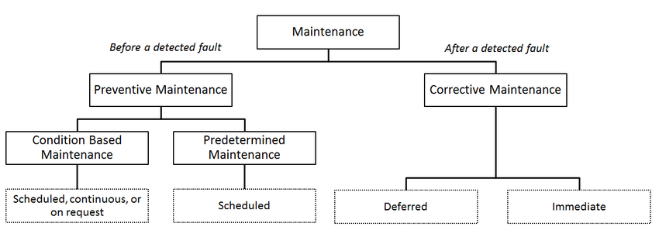

Figure 1: Types of maintenance according to EN 13306 standard

The strategies of Corrective Maintenance (CM) and Preventive Maintenance (PM) have been employed since the early 1990s. Corrective maintenance aims to restore a system after a failure, often resulting in unpredictable consequences and higher costs. Preventive maintenance involves planned interventions to keep equipment in good condition, intending to address issues before they lead to failure. However, the challenge lies in flawlessly scheduling maintenance well in advance. Increasing demands for system reliability have diminished the effectiveness of preventive maintenance, with the downside of not always considering the actual system state, leading to potential unnecessary procedures and additional costs(Coandǎ et al., 2020; Rojek et al., 2023).

In recent years, a third strategy, Predictive Maintenance (PdM), has gained prominence. Predictive maintenance represents a significant advancement over corrective and preventive maintenance strategie(Coandǎ et al., 2020)s. It leverages the power of data, analytics, and machine learning to predict equipment failures before they occur, enabling timely intervention. Predictive maintenance involves continuously monitoring the condition of the transformer and analyzing this data to identify signs of potential failures. This is achieved using advanced machine learning algorithms that can learn from historical data to identify patterns that precede a failure(Carvalho et al., 2019).

### TRANSFORMER FAULTS AND PREDICTIVE MAINTENANCE

Transformers, often unsung heroes within the power grid, play a crucial role in stepping down high-voltage electricity to ensure its safe delivery to homes and businesses. However, these intricate machines are susceptible to malfunctions, and when transformer faults arise, they can pose significant challenges to grid reliability and stability. These faults can be broadly categorized into electrical, mechanical, and dielectric faults.

**Electrical Faults** such as short circuits and open circuits can disrupt the normal flow of electricity, leading to overheating and potential catastrophic failure. These faults are often caused by insulation breakdown, loose connections, or foreign objects entering the transformer.

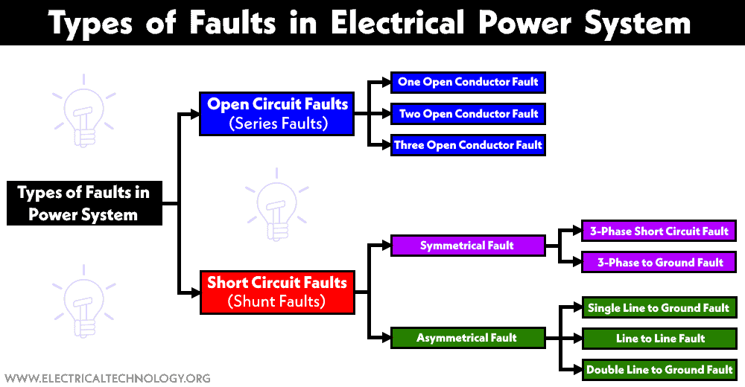

Figure 2: Electrical Faults of Transformer

**Mechanical Faults** like winding displacement and core movement can lead to uneven current distribution, increased noise, and compromised efficiency. These faults are typically caused by vibrations, thermal expansion, or manufacturing defects.

**Dielectric Faults** involve issues with the insulating fluids within the transformer. Dielectric breakdown and partial discharge can degrade the insulation, leading to internal arcing and potential catastrophic failure.

In this context, rather than adhering to a predetermined schedule (preventive maintenance) or responding reactively to failures (corrective maintenance), a proactive maintenance strategy is employed based on the predicted health of transformers. Predictive maintenance, utilizing machine learning, analyzes grid stability data encompassing load patterns, voltage levels, and frequency fluctuations. By leveraging this data, the system can predict potential transformer failures. This proactive approach enables scheduled maintenance interventions, aiming to prevent failures and minimize downtime, contributing to a more efficient and reliable power grid.

### PRIDICTIVE MAINTENANCE AND ELECTRICAL GRID STABILITY DATA

Electrical grid stability data refers to the information that reflects the condition of the electrical grid, including parameters such as voltage, current, and frequency. This data is crucial as it ensures the grid’s safe and efficient operation, and guarantees the delivery of power as required. By monitoring this data, utilities and grid operators can identify potential issues before they escalate, enabling them to take preventive measures. This approach helps avoid expensive repairs and power outages, and ensures public safety.

**Voltage Data:** This type of data includes measurements of voltage levels at various points within the electrical grid. Monitoring voltage levels is critical for ensuring proper equipment function and power quality. Variations in voltage can indicate issues such as overloading or equipment malfunctions, affecting the reliability of electricity supply.

**Frequency Data:** Frequency data involves measurements of the frequency of alternating current (AC) within the grid. Grid frequency is typically maintained at a constant value, and deviations can signal imbalances in supply and demand. Frequency data helps operators regulate grid stability and address issues like overloading or generation shortages promptly.

**Load Data:** Load data pertains to measurements of electricity demand or load levels across the grid. Understanding load patterns helps operators anticipate peak demand periods, plan for capacity requirements, and optimize resource allocation. It provides valuable insights into consumer behavior and usage trends, guiding effective grid management strategies.

**Power Quality Data:** Power quality data encompasses measurements of various parameters related to the quality and reliability of electrical power. This includes factors like voltage harmonics, voltage unbalance, and transient voltage fluctuations. Monitoring power quality ensures that electricity meets acceptable standards and helps identify issues affecting grid performance.

**Fault Data:** Fault data provides information on electrical faults or disturbances within the grid, such as short circuits or equipment failures. Rapid detection and response to faults are crucial for minimizing downtime and ensuring grid reliability. Fault data aids in pinpointing the location and severity of faults, facilitating timely interventions and restoration of service.

Electrical grid stability data can provide valuable insights for predictive maintenance programs. By monitoring stability metrics over time, operators can identify trends, patterns, and early indicators of equipment degradation or impending failures. This proactive approach allows for timely maintenance interventions, reducing the risk of unplanned outages and optimizing asset performance.

### PREDICTIVE MAINTENANCE AND MACHINE LEARNING

Machine learning, a subset of artificial intelligence, involves developing algorithms and statistical models that enable computer systems to learn and make predictions or decisions without being explicitly programmed. Machine learning, along with the Internet of Things (IoT), plays a pivotal role in predictive maintenance. IoT devices, essentially sensors or equipment, continuously feed real-time data to centralized systems. This influx of data, combined with machine learning models, allows for incredibly precise predictive maintenance schedules. The three main ML techniques employed are.

**Supervised learning algorithms** like XGBoost and Random Forest excel at pattern recognition. Trained on historical data of transformer failures and corresponding sensor readings, they learn to identify the intricate relationships between sensor data and impending faults(Janiesch et al., 2021). Just like an experienced doctor analyzing test results, these algorithms can trigger alarms based on subtle anomalies in real-time data, predicting failures before they occur.

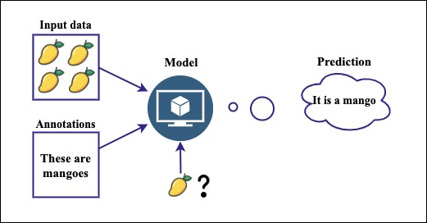

Figure 3:Supervised learning algorithm

**Unsupervised learning algorithms** like k-means clustering take a different approach. They explore vast amounts of sensor data, searching for hidden patterns and groupings that might not be readily apparent to traditional methods. Similarly, in fault detection, it can uncover new failure modes or early signs of trouble, providing deeper insights into the health of the equipment .

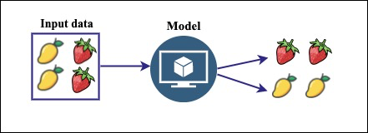

Figure 4: Unsupervised learning algorithm

**Deep learning** takes things a step further with its ability to analyze complex data streams like vibration signals or infrared images(Breviglieri et al., 2021; Janiesch et al., 2021). Convolutional neural networks (CNNs) can be trained on thousands of transformer images, both healthy and faulty. They meticulously dissect each image, extracting minute features and patterns that human eyes might miss.

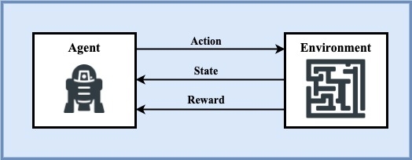

Figure 5: Deep learning algorithm

In predictive maintenance, machine learning algorithms analyze historical data to identify patterns that precede a failure. This allows for proactive scheduling of maintenance activities, potentially preventing failures and reducing downtime(Coandǎ et al., 2020). Predictive maintenance has been reported to reduce breakdowns by 70%, increase productivity by 25%, and lower maintenance costs by 25%(Rojek et al., 2023). This approach, combined with machine learning, is reshaping how businesses operate, making them more proactive, efficient, and resilient.

### RANDOM FOREST ALGORITHM

As a powerful ensemble learning technique, Random Forest harnesses the collective wisdom of multiple decision trees to conquer complex problems in supervised learning. It can be used for both Classification and Regression problems in ML This ensemble learning powerhouse combines maze of sensor readings and historical trends, boosting accuracy and resilience in identifying potential failures. As the name suggests, “Random Forest is a classifier that contains a number of decision trees on various subsets of the given dataset and takes the average to improve the predictive accuracy of that dataset.” The greater number of trees in the forest leads to higher accuracy and prevents the problem of overfitting. The below diagram explains the working of the Random Forest algorithm:

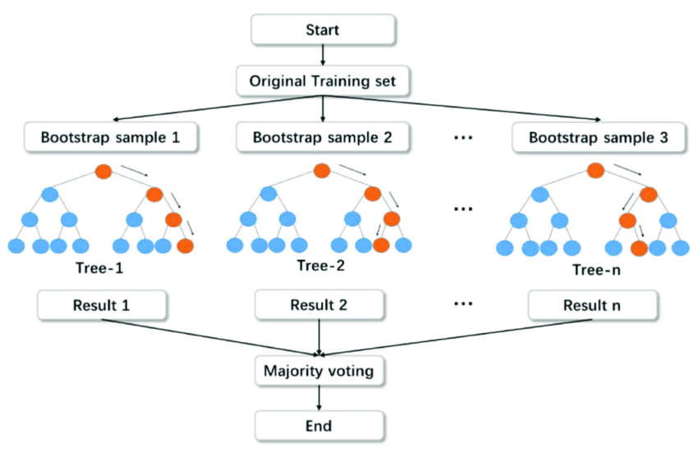

Figure 6: Random Forest Algorithm

In the context of **classification**, the algorithm begins by randomly sampling subsets of the training data with replacement. For each subset, decision trees are constructed using group of sensor readings and historical trends. During the construction of these trees, a subset of features is randomly selected at each node. The optimal feature and split point are chosen based on their ability to minimize the Gini impurity after splitting. Gini impurity is a measure of the uncertainty or impurity of a set of samples, with lower values indicating purer nodes.

The Gini impurity, denoted as Gini(D), for a dataset D with C classes is calculated using the formula:

$$Gini(D)=1-\sum_{i=1}^{C}{p_{i}^{2}}$$

Here, pi​ is the probability of class i in node D.

While classification focuses on distinct categories, Random Forest also ventures into the realm of **regression.** Here, each tree becomes a treasure hunter, analyzing relationships between features and actual values to estimate the remaining lifespan of transformers based on their current readings. The final predicted value for a sample is the average of predictions by all the individual trees, calculated as:

$$\hat{y}(x)=\frac{1}{k}\sum_{i=1}^{k}{{\hat{y}}_{i}(x)}$$

Here, y^​i​(x) represents the predicted value by the i-th decision tree for sample x.

### EXTRA GRADIENT BOOSTING (XGBOOST) ALGORITHM

## REVIEW OF RELATED WORKS